Front Page
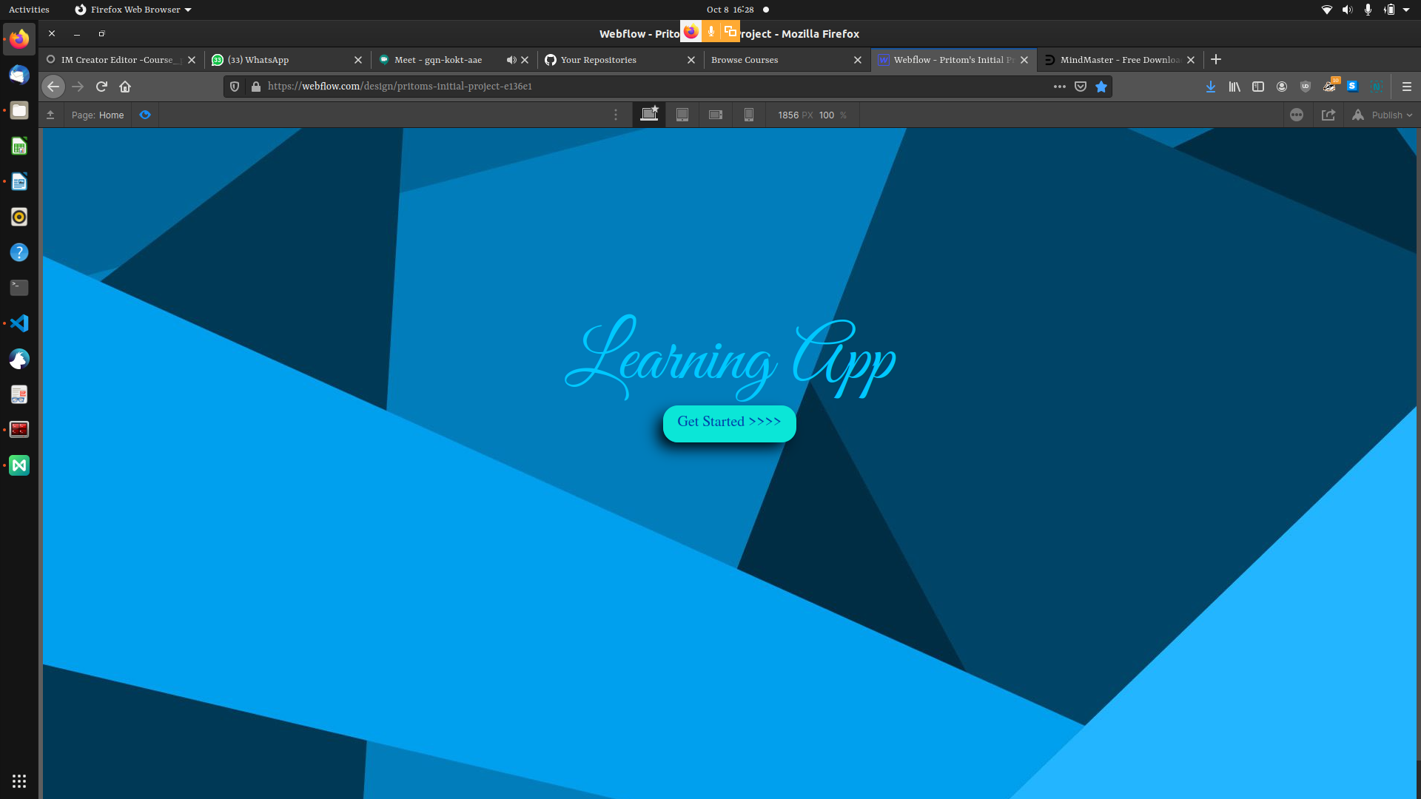
The front page will take the user to the login page

Login /Sign Up

DashBoard
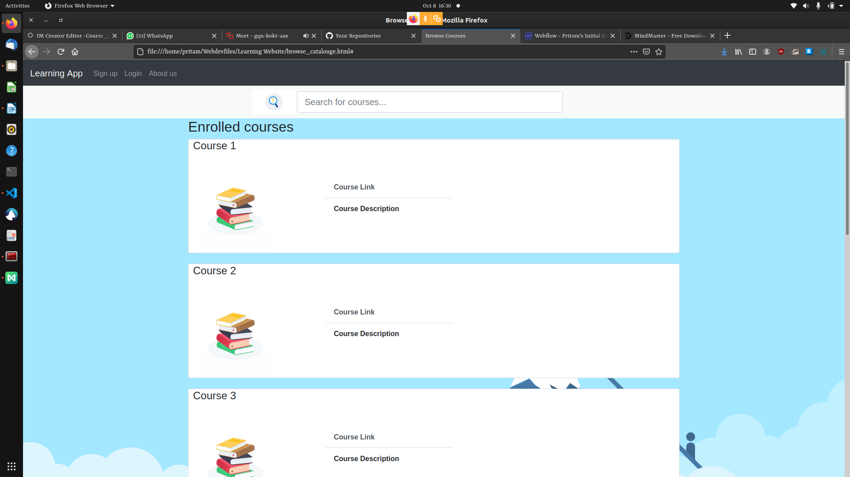
The Dash board will contain all the enrolled courses where we can search all the courses and enter whatever course we want here is also the options to go to the profile page.

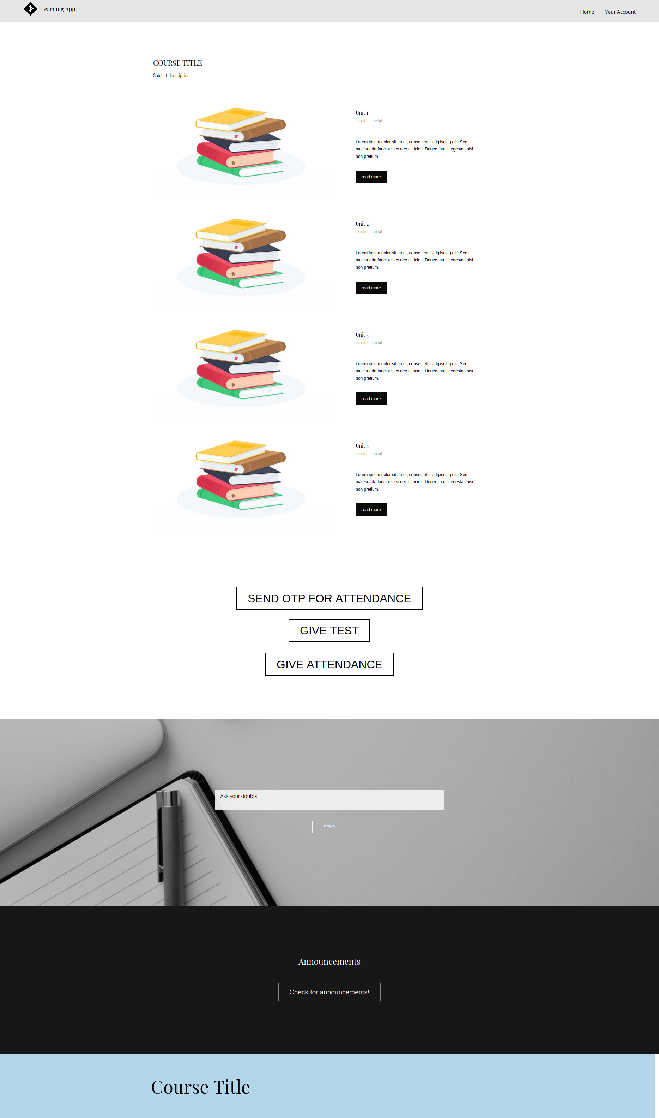
Course Page
The course page will provide the syllabus details, course materials, test and attendance giving facility and send otp for attendance facility. It also has a doubt asking text box and annuncements section.

Announcements
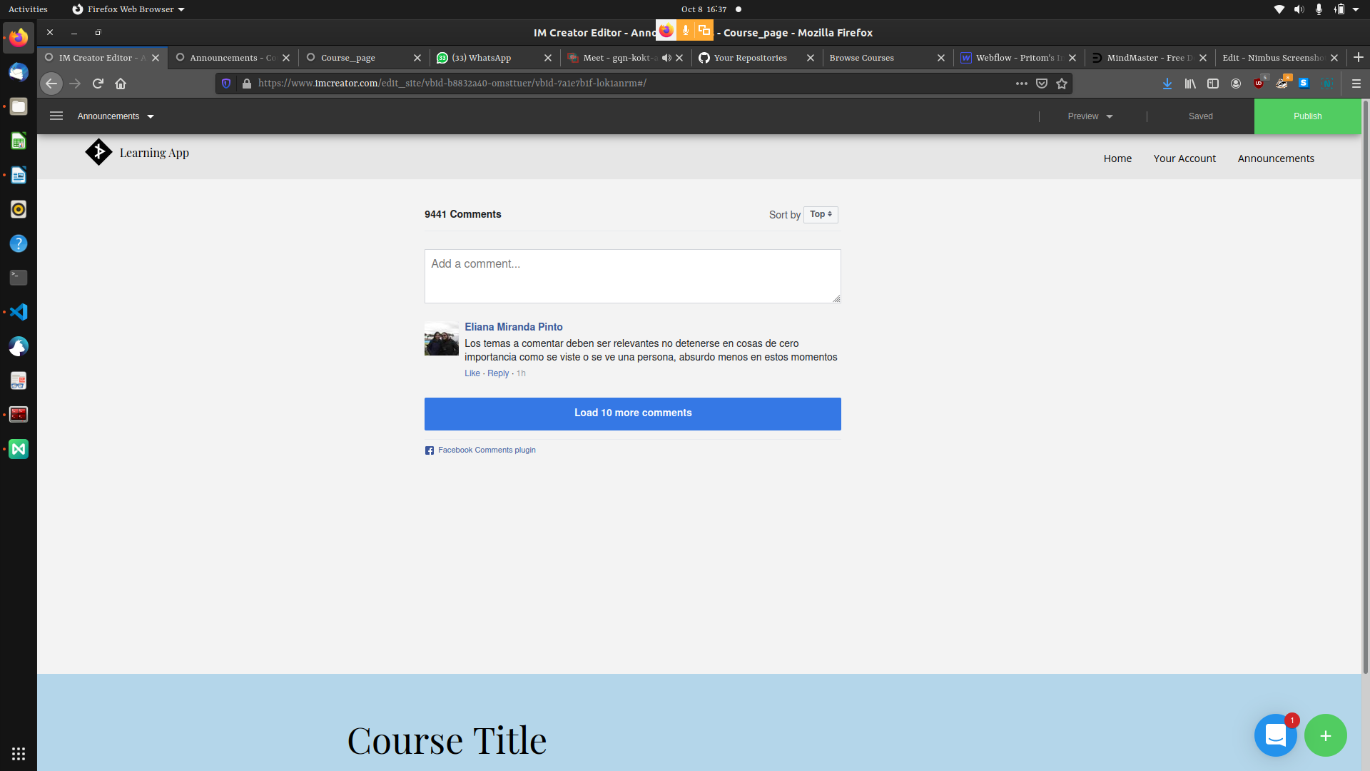
This page will provide facility to both teachers and students to communicate with each other.

Create Students

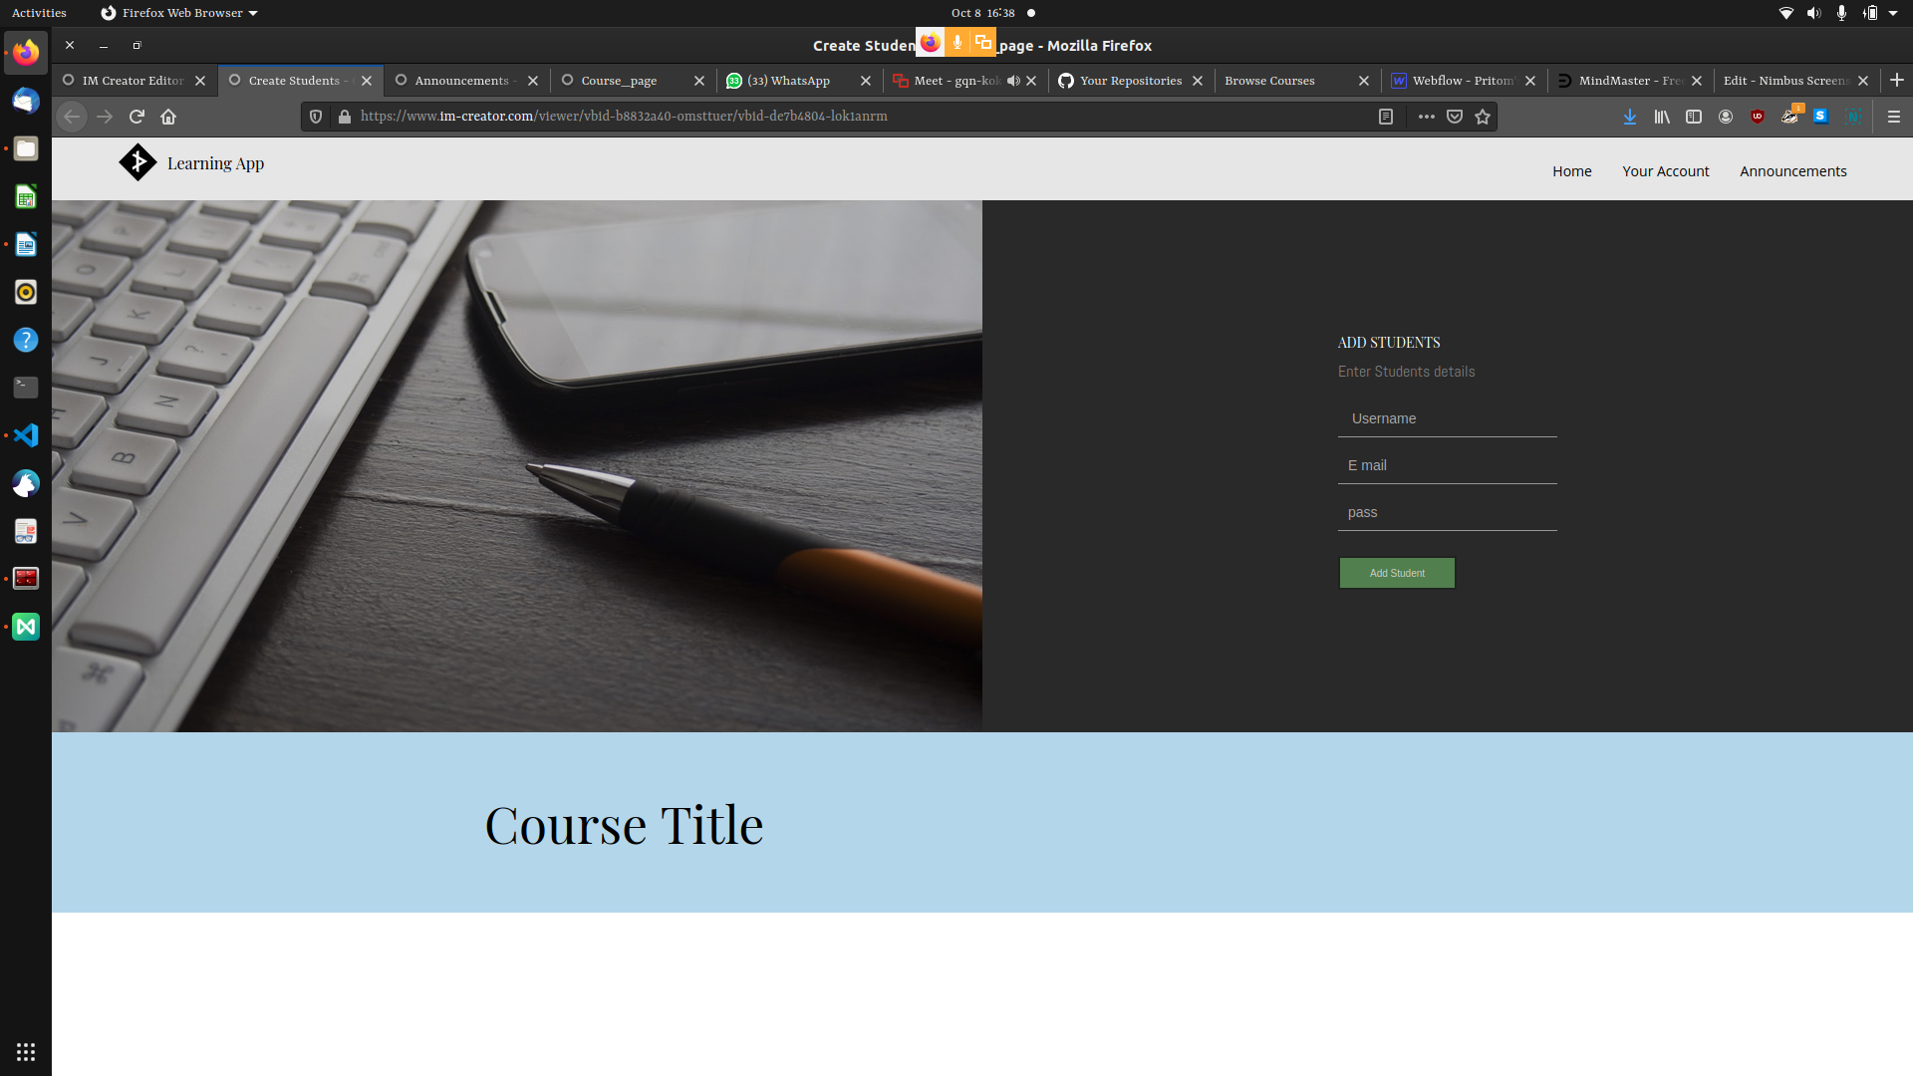
In this page the teacher can create student accounts for the sudents to log in.

Login page
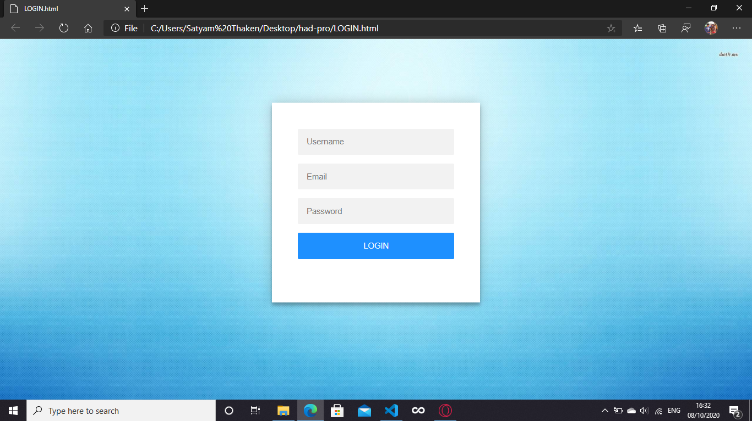
This is the main login page.

Profile Page

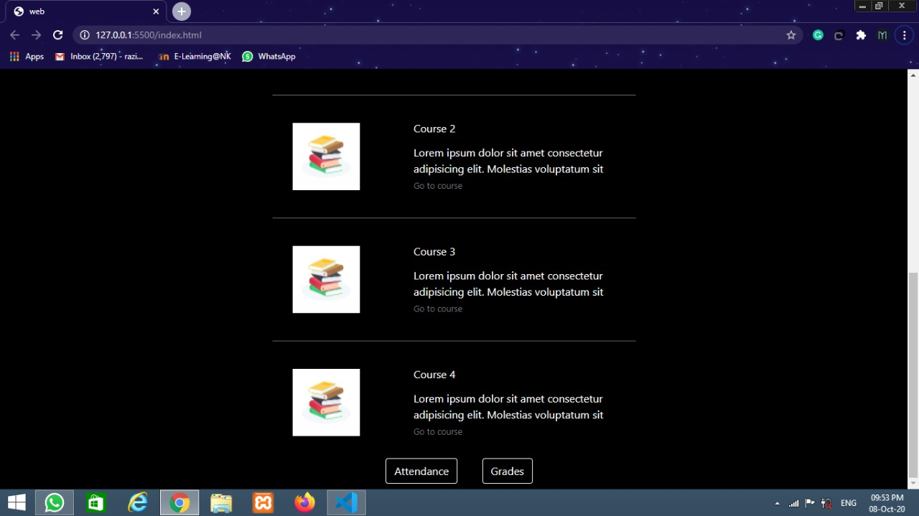
This page will show the details about the user and the subjects and it will also allow the student to acces their attandace card and grade card.

Grade Page
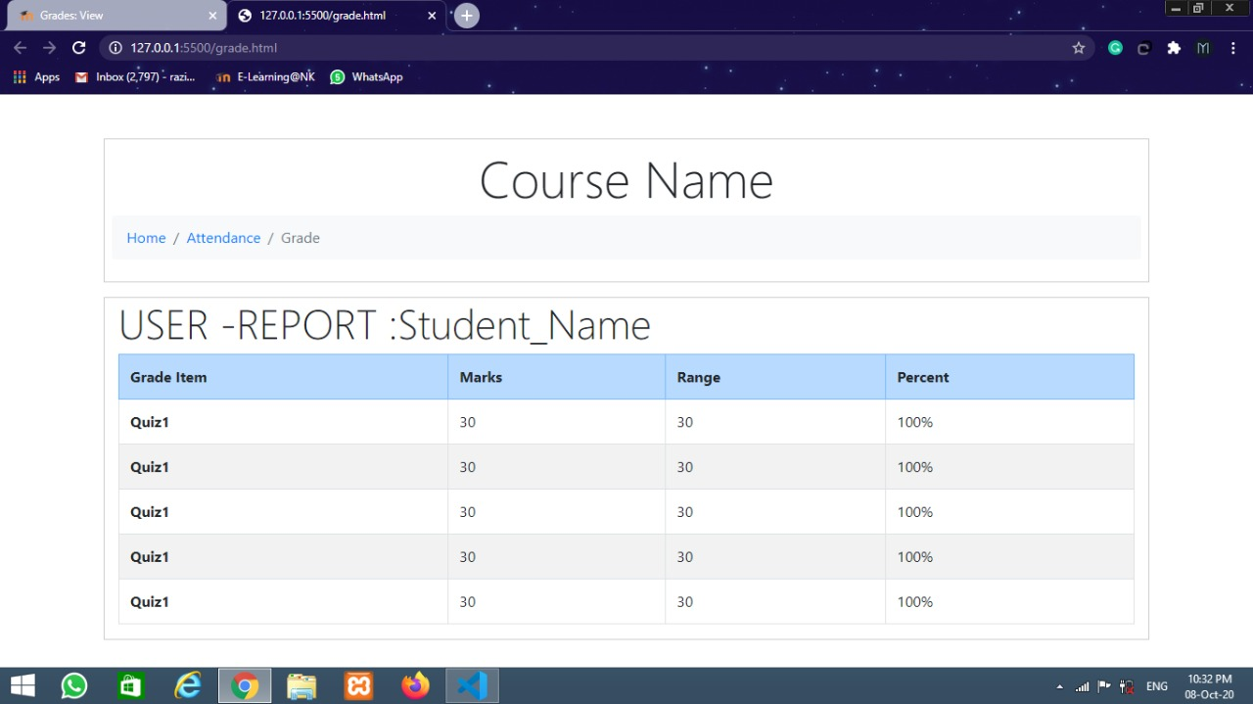
This page shows the details of the Grades of the sudents.

The entire flow of the pages



